**Changing Order Export SFTP location**

When to use?

* During planned maintenance on CIMS
* During VPN connection issue between MuleSoft CloudHub environment and FatFace on-premise systems connectivity issues (mainly CIMS)

Pre-requisites

* One should have the login account to Demandware business manager and should have the “Administrator” role assigned to his profile.
* Before making a change in the Demandware job, make sure that the last job was successfully completed and you are not saving any changes while the job is running.

Steps to be used

* Login to Demandware business manager using below link.

<https://production-web-fatfaceltd.demandware.net/on/demandware.store/Sites-Site/default/ViewApplication-DisplayLogin>

* Click on drop down arrow next to “Administration” and click on “Job Schedules” link under Operations.

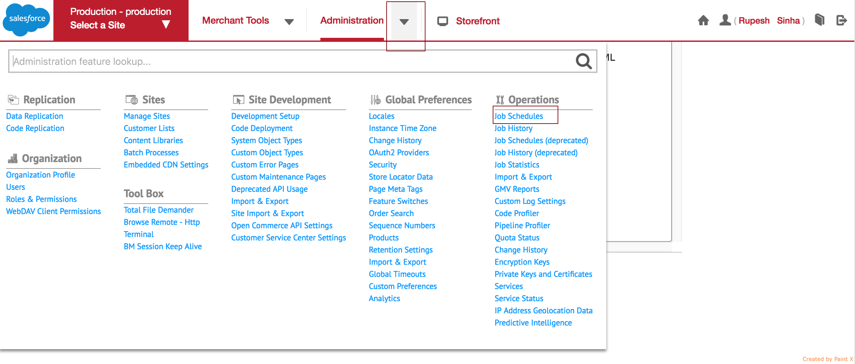

* Click on “Mule-Export-Orders” job

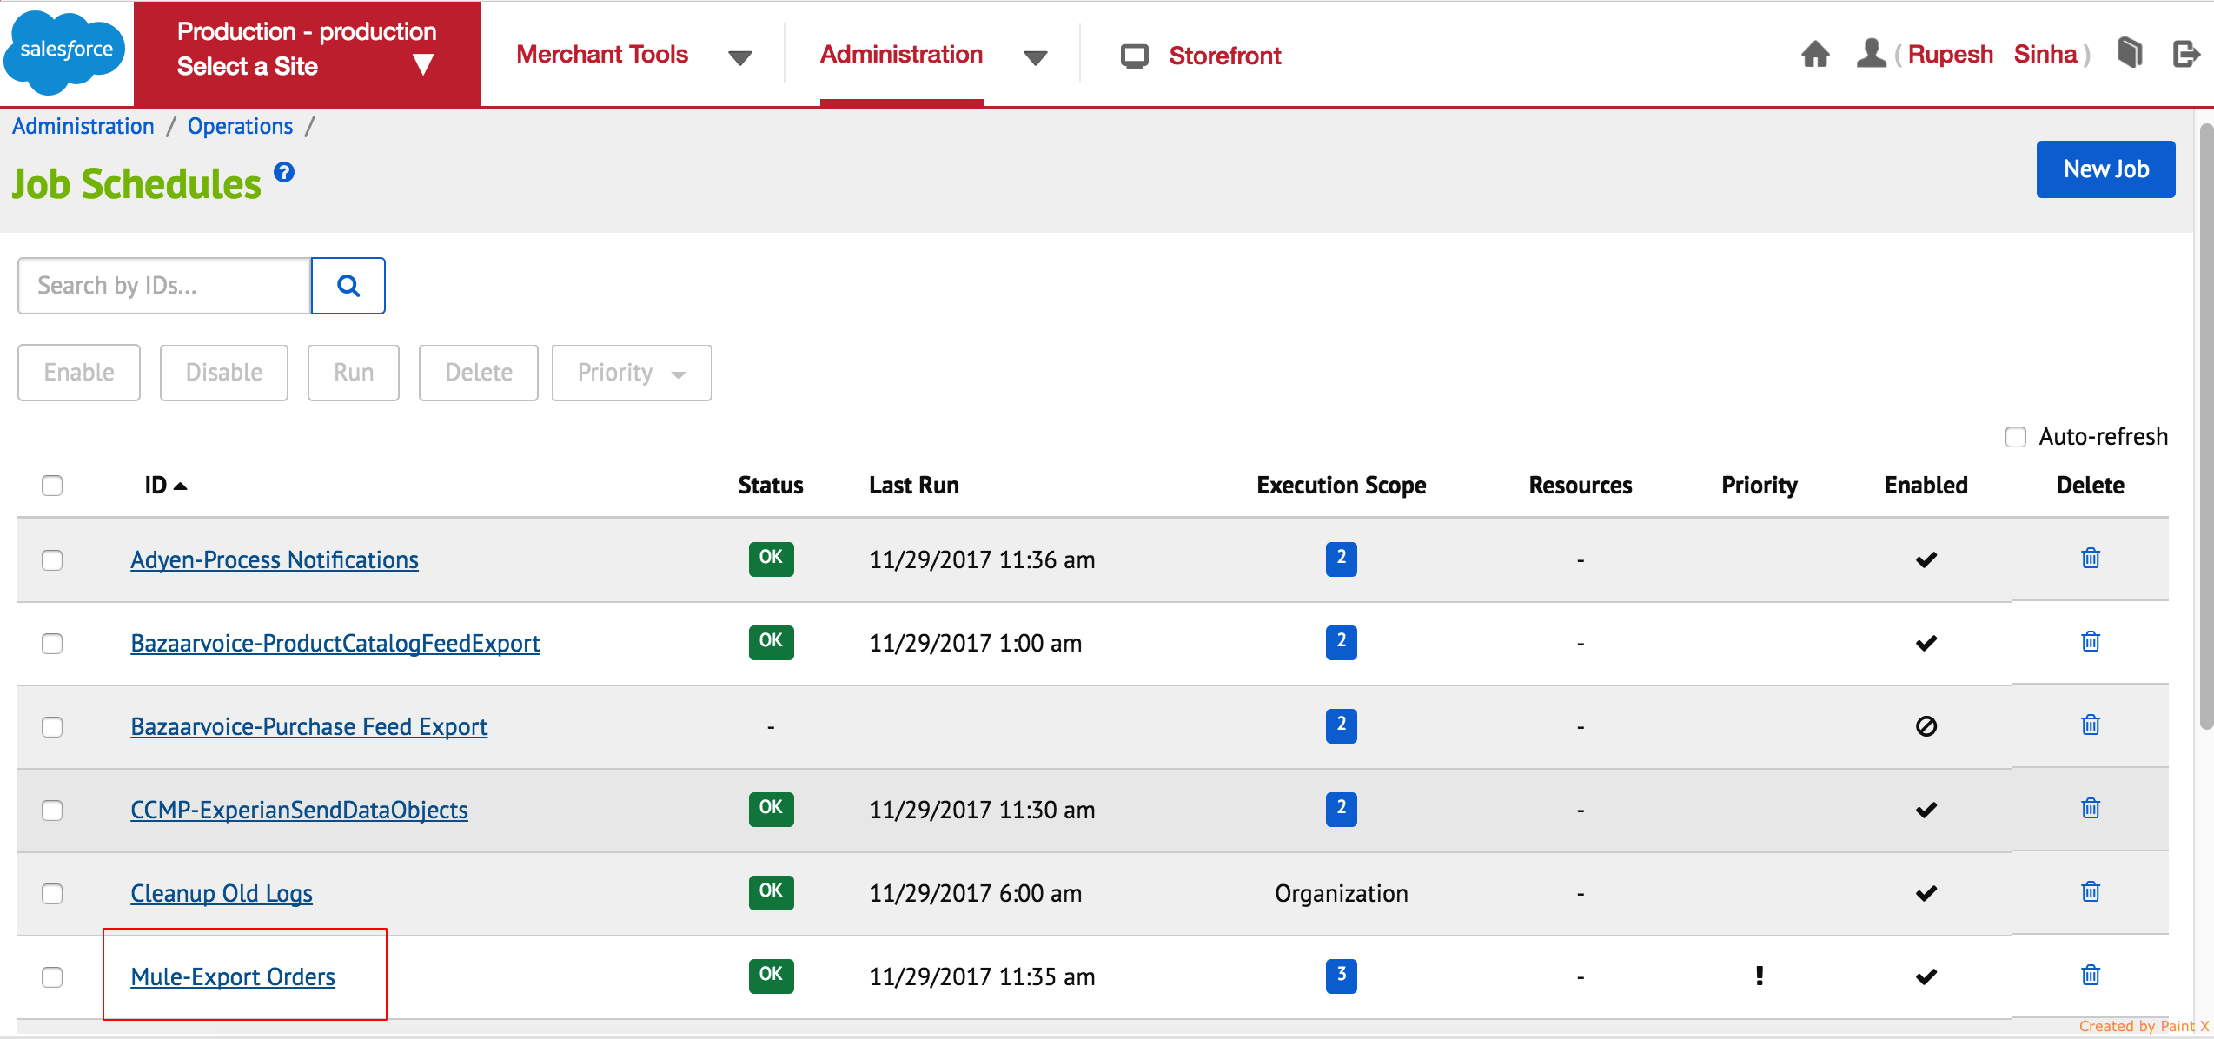

* Click on “Upload To SFTP” under “Step Configurator”. A popup screen shall appear on the right.

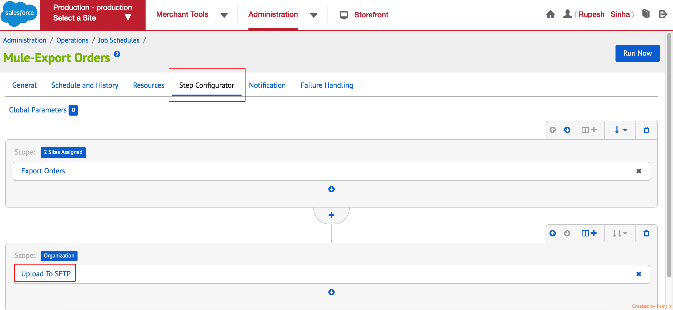

* Scroll down to find text box for “remoteFolder”.

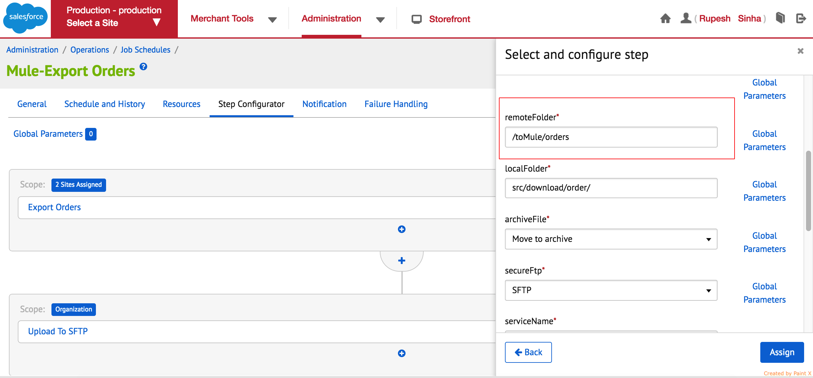

* Change the value inside remoteFolder text box to “/toMule/orders_bkp_queue” if you want don’t want to process the orders due to any maintenance on CIMS side or VPN issue. Change it to “/toMule/orders” if you want to process the orders through Mule as normal i.e., after the maintenance is complete and it’s fine to process orders through the automated process.
* Click on “Assign” button on the bottom right corner.